1. 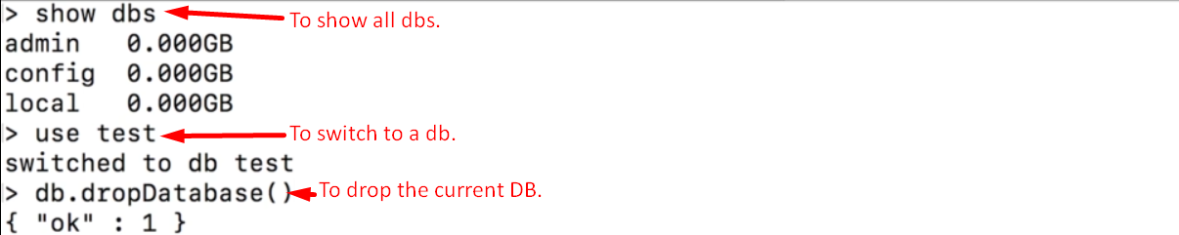
2. Let’s create a database companyData and inside this db, let’s create companies collection. The purpose is to showcase the different data types.
3. **Study** 🡺
   1. **Field name:**  name
      1. **Type**: Text. Enclose within single or double quotes doesn’t matter as you’re using shell which is javascript based but for programming language, it matters.
   2. **Field Name**: employees.
      1. : This would be treated as floating point number because we’re using shell which is javascript based.
   3. **new Date(), Timestamp()**; Functions provided by the shell as shell is javascript based. There are equivalents in the drivers for the different programming languages though. You will find the exact method you need to call in the driver docs.
   4. Here we’re on the page of the MongoDB Nodejs driver.  
      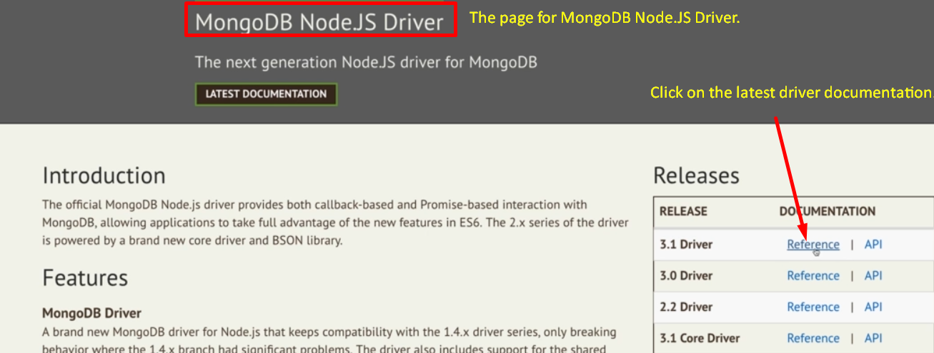  
      Such release references are available for all drivers and in the documentation for the driver, you find detailed instructions on installation and how to use it and you should also find API documentation which is simply a list of all features included in it.  
      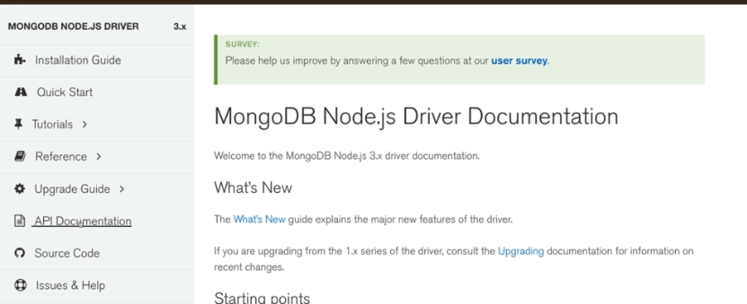
4. 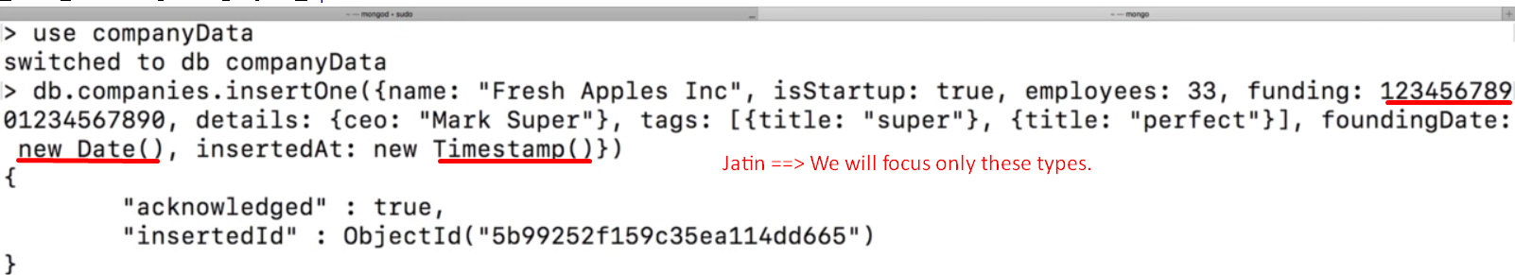
5. We were trying to store 12345678901234567890 but it was stored as 12345678901234567**000**. The selected part is nullified or cut off because the no is too big. The normal number that the javascript can store is 64bit floating point value. If you want to store very big number, store it separately as string.
6. 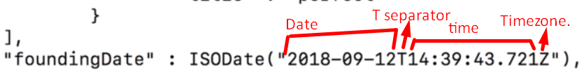
7. 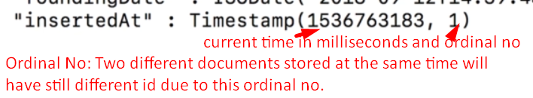
8. Let’s talk about number a little bit more even though we have whole module for this.
9. 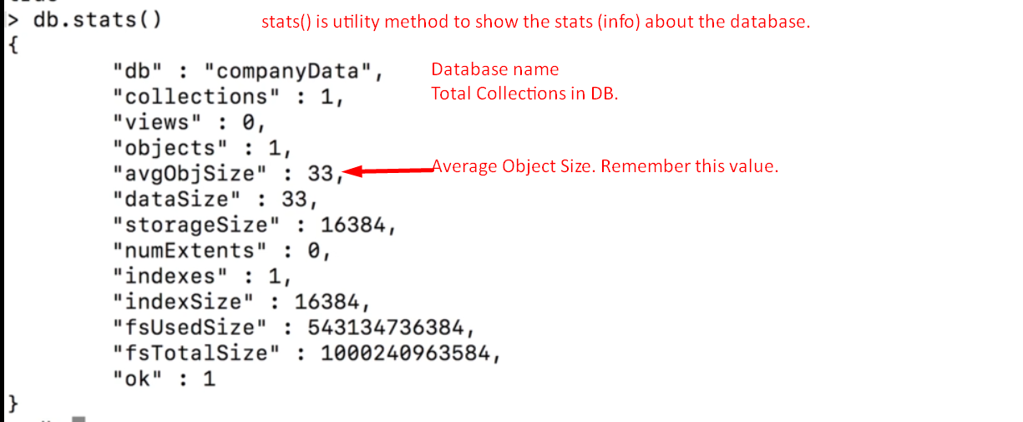
10. 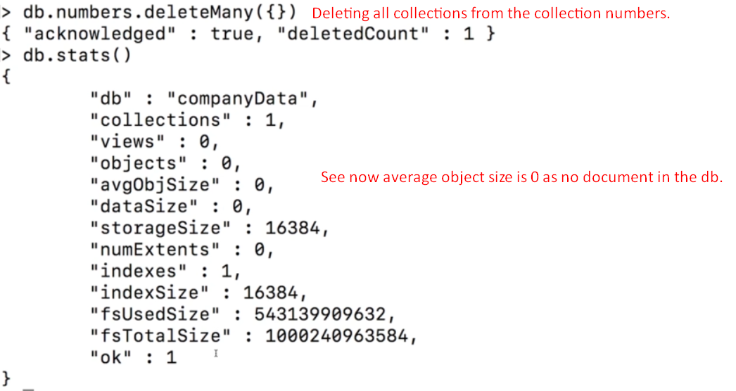
11. 